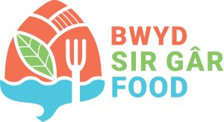
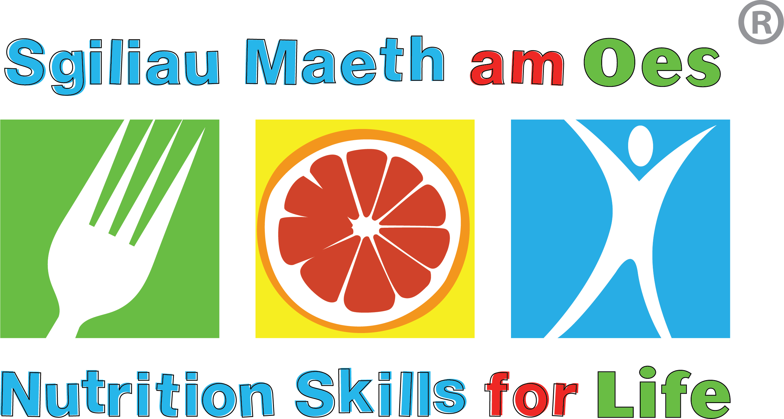



COMMUNITY FOOD & NUTRITION SKILLS
Booking form

Course Title: Agored Cymru Community Food & Nutrition Skills Level 2 | NH22CY001
Start Date: THURSDAY 22/05/2025
End Date: THURSDAY 26/06/2025
Duration: 5 WEEKS (face-to-face)
Venue: LLANDYBIE MEMORIAL HALL, AMMANFORD, SA18 3UR
Time: 9:30 AM - 2.30 PM

*Please be aware that there will be no session held during Half Term on 29/05/2025*

Please complete your details in full (print if written):
All data will be processed in accordance with Data Protection legislation and kept in line with Hywel Dda University Health Board Retention policies.
SURNAME
FORENAME
JOB TITLE
ORGANISATION
COUNTY
CONTACT NAME
(If different)
EMAIL ADDRESS
CONTACT NUMBERS
WORK / MOBILE

Thank you for your interest.
Please return this form to: Hidieteticteam.HDD@wales.nhs.uk and state BOOKING REQUEST in email subject field.
If you are unable to email, please contact us on 01437 773357

